2017年寒假普文农工大学访学总结报告

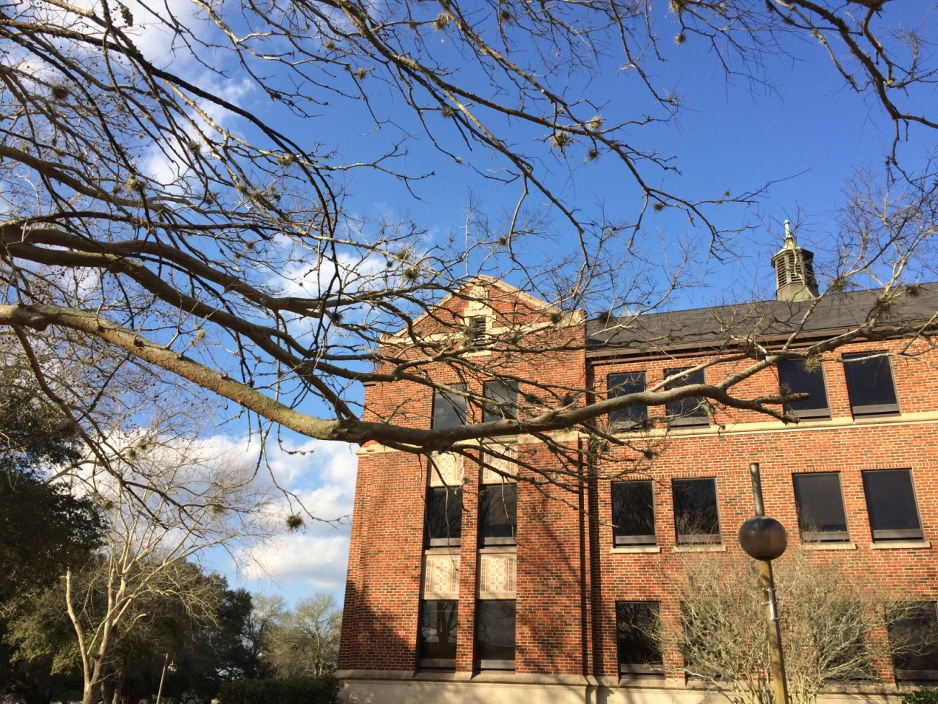

学院：英文学院
年级：2014级16班
姓名：孔琪

2017年普文寒假访学总结报告
Summary of XISU-PVAMU Exchange Program
School of English Studies
英文学院
KONG QI 孔琪

Financial Independence
According to Kynan, my peer in PVAMU, the tuition for one year in college is about $15,000. I asked him whether his family has helped him with the tuition fees, he said it depends. Kynan works as an assistant student for the deen of Science Art Department. He earns $10 per hour, and he works between classes from Tuesday to Friday. Kynan got his first job when he was 15 years old. For some students who have full scholarship like Christian Farley, they don’t need to pay for the tuition or rent or any other expenses in school, therefore they don’t have to work to make a living. For those who don’t have full scholarship like Jamal Sawyer, he had got loans from the bank. He only needs to pay it back in four years after graduation. Jamal also has a part-time job but it is very flexible. He once worked for a whole summer holiday and earned $4,000. He now usually earns $20 per hour at his part-time job. Ervin is very busy working in his spare time, and he always goes to work after class immediately. I also asked some other students about the college tuition fees and their financial income. Most families are willing to pay if they can afford it but the tuition is not that affordable for some families. At the same time, school will provide many jobs for students in campus, giving working opportunities for them.
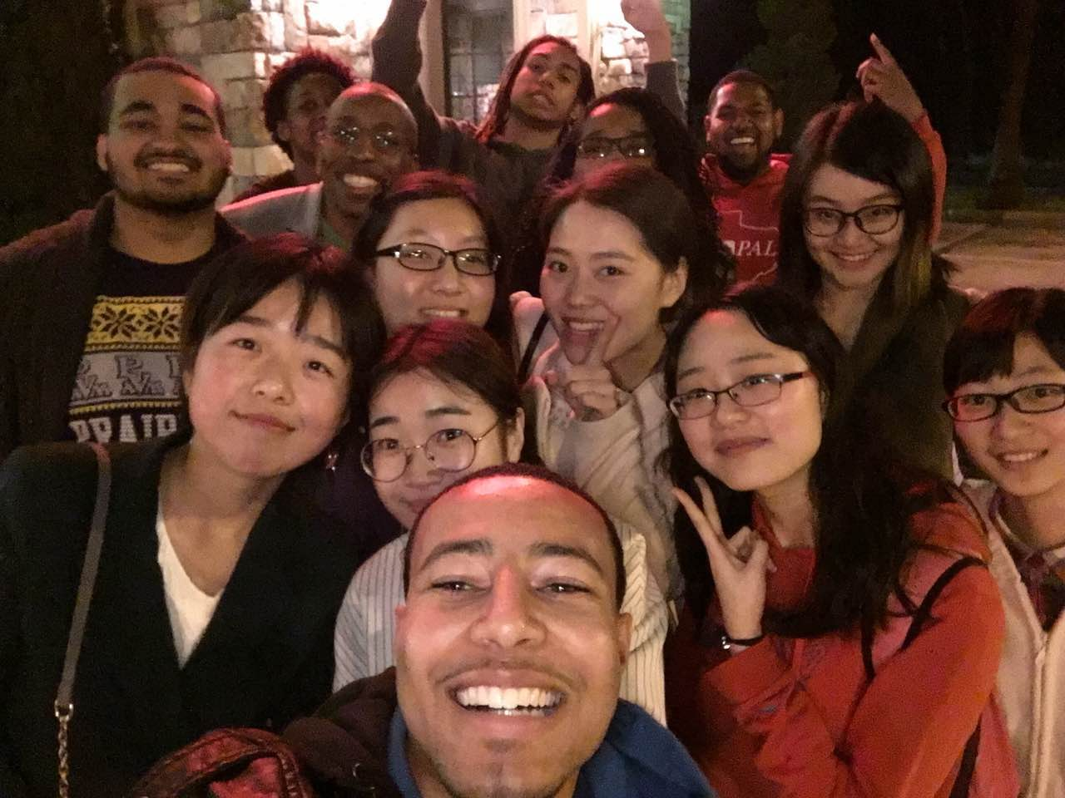
Our first group photo together

Student Community
I have asked some honor students about Model APEC, and most of them had no idea what Model APEC is. They don’t have Model APEC in PVAMU. But there are many student communities that we don’t have in XISU. For example, Purple Jacket is a student community that focuses on gender equality and female rights. Their activities are less formal compared with some academic communities. They will hold ice cream party, pajama party and some voluntary works as well. In University of Texas at Austin, they have Orange Jacket which is the model for Purple Jacket of PVAMU.

We went to Professor. Coffman’s public speaking class and witnessed how their students practice public speech and debating. Although the style and standard varied a lot, but all of those students were very confident and some of them had very good sense of humor. I could see that they were enjoying the time while standing on the stage and giving the speech or arguments. I hope a lecture like this can be started in XISU someday.

Then there are many voluntary communities like Men and Women of Vision, which also focuses on some voluntary work not only at school but also in society. Another community is called Brotherhood of Leadership. It is a community that consists of all the leaders of some important communities in the university.
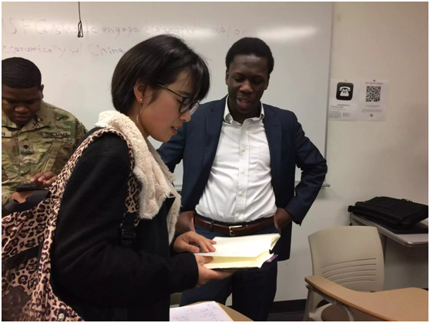
Li Ping and Ervin after English debating contest

Different Classes
Although my peers’ majors are biology, engineering and politics, I attended physics, Chinese, Texas Government, chemistry lab and math but no classes concerned with biology or other classes that I took interest in. but I did learn something from those different classes. Apart from our peers’ classes, we also had classes about finance, architecture, business and films. I did enjoy the film class and architecture class.
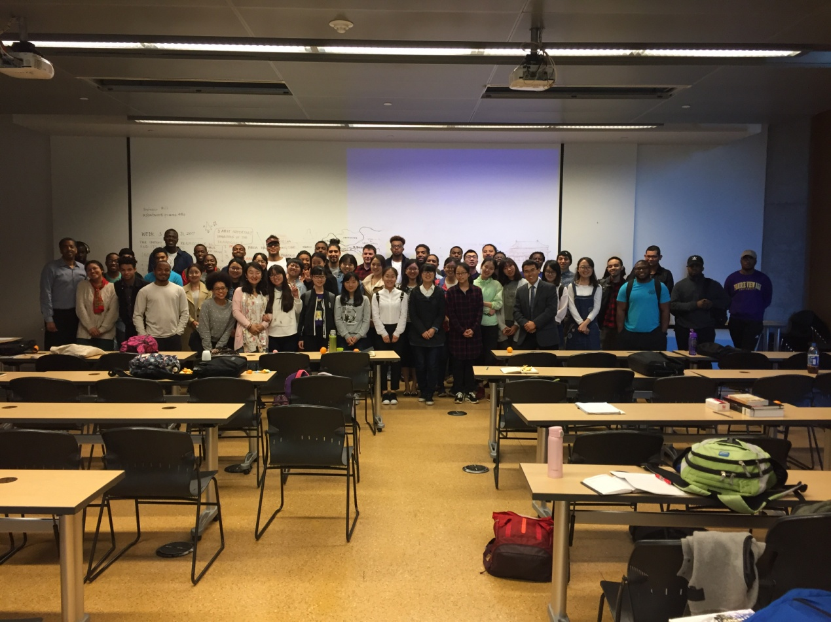
Our group photo at Architecture class

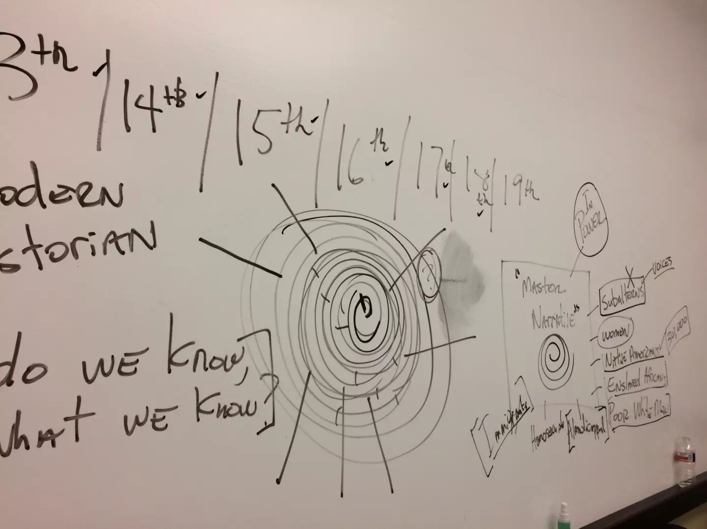
Dr Wilson’s history class
Suggestions

Firstly, daily reflection might not need to be held too often. Once a week would be good, and it can be set on the every Friday afternoon. Since daily reflection can be about two-hour long sometimes and it does occupy too much time that is not needed. Students can simply gather all the questions and doubts they have for the past week and share them with teachers on Friday afternoon.

Secondly, living on campus would be better than living in the hotel. Personally speaking, I think living on campus with foreign students in the apartment can help us get to know each other, know the cultural difference and experience the colorful American campus life better. Also, Chinese students can improve their English and PV students can practice their Chinese as well. They will build a much stronger friendly relationship. Besides, living on campus means Chinese students can make better use of all the school facilities like the Rec Center and Library. They can also better experience the school life with their peers and roommates. Living in the hotel has already set a time limitation on students’ everyday life. They have to get up at 6:30am and go back to hotel at 6:30pm.

Thirdly, the transportation is poor. For students from XISU, most of us are girls. Girls need to go shopping sometimes, not that often but we do need to buy something for ourselves or families and friends. But there’s no bus nearby and the taxi is not only hard to get but also expensive. We can only rely on friends from PV or teachers from CI to take us to the places we want to go to. However, sometimes our friends and teachers can be busy or unavailable. So that means we will have to stay in the hotel for the whole day or the whole weekend.

Fourthly, as for the field trip, I think a visit to church can be arranged. Going to church on Sunday is a good way for students to know American culture better, and I believe most students are rather willing to visit. But very few students had the opportunity to go to church in this exchange program.

Fifthly, peer day can be more flexible. I think peer day is usually good, but sometimes it is kind of boring or even tiring. One of my peers was really quiet and she seldom talked to me first. I always was the one who started all the conversation because it was awkward to always be silent. But whenever she was with another foreign student, they talked a lot and sometimes totally forgot my existence. I tried to join their conversation but failed. I think XISU students can be given the chance to know their peers’ majors first, and then they might find the peer that suits their major.

Sixthly, more classes or lectures can be arranged for XISU students. I was looking forward to more classes as long as I could understand most of the class. Sometimes we arrived at school at 7:45am, and the first class was at 10:00am or 9:00am. I think the free time could be efficiently used whether by students themselves or at the class.

游学周记总结
与美国同学相处篇

因为大家住的旅馆没有公共交通，距离商场较远购物不便，在第一周和Honor Students吃饭的时候他们主动offer可以在我们有时间的时候带我们去outlets 或者downtown shopping。本周末Christian, Jamal, Breya, Demo, Joshua 等普文的朋友在上午十点开车来接大家去了outlets。大家陪了我们将近一整天，在大家购物的时候一直跟在周围，介绍推荐一些商店、给出建议。有同学在跟店员交流的时候他们都很关心怕大家交流有问题，主动上前提供帮助。在车上也交给大家一些美国的一些slang 或习惯。回来的路上我们才知道Christian熬夜学习到今天的早上六点，然后十点有来带我们去购物，陪了大家一天。
在购物的时候，在一些品牌店，美国同学经常说“太贵了”，“大学生没有钱”，“买华为不要买苹果”，包括在NIKE，也会推荐一些值得买的东西，建议去其他店看过再决定在哪家买，对于金钱的管理很有计划。
在周四晚餐自理的时候，Honor Students 主动带我们到附近的Linda一起 吃了墨西哥餐，告诉我们怎么给小费，大家坐在一起聊天十分开心。木兰还在一天晚饭之后带我们参观了她的宿舍，见了她的舍友，还带我们去了学校的保龄球场，这是我们从未体验过的美国大学校园文化。虽然中美文化之间会有许多cultural shock, 太多的不同，但很多时候又觉得我们是一样的，所想所闻，大家总会有许多共同之处，很幸运能在这里遇到一群很棒的朋友。去上林老师的汉语课时，因为凳子不够，Honor Students 中的所有男生都主动把凳子让了出来自己站着。

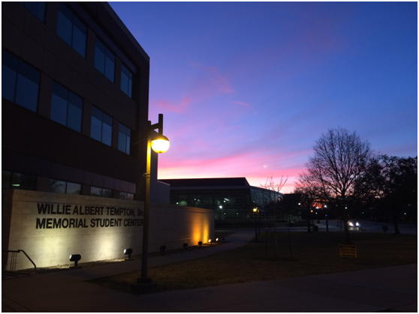
How I love the sunset of Texas... It's always so breathtaking.

Warmth from Local People
周六field trip我们去了“德克萨斯的诞生地”——Washington on the Brazos. 在参观了历史遗留的景点之后，我们去了当地的农场，近距离感受德克萨斯当地农民的农牧生活。在当地的农场，喂牛、骑马，带领我们的当地人十分热情有耐心。这里的农场和国内十分不同，因为动物享有特定的权利、一定的空间，这是动物所享有的基本权利。之后去的Cannery Kitchen 是当地的government charity，每周会有固定的两天提供免费的食物给人们。就在这样一个不起眼的小镇，我们接触到的人们都是这样的热情好客，在对信仰的坚守下奉行着faith mission: Helping people find hope, dignity and purpose for their lives. 联想到国内的福利慈善事业，如果能和这里的faith mission 一样从一餐一食、生活里的小事做起，人们会学会感恩、社会会令人感到温暖。
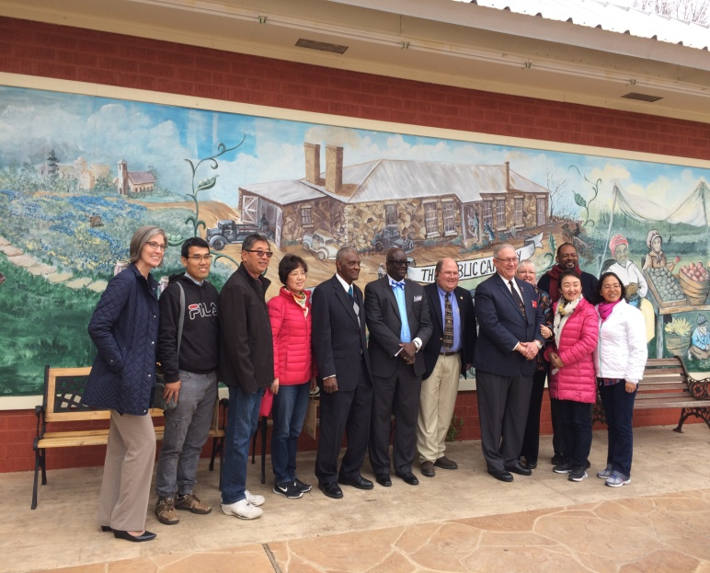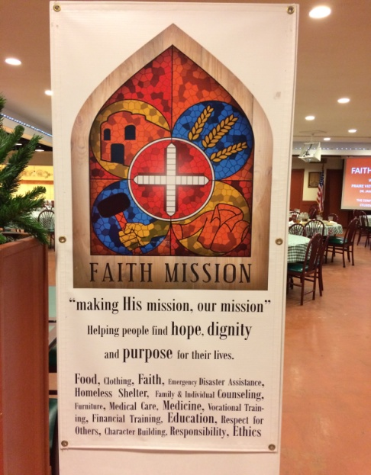

交流感悟
在前往美国普文之前，我曾经想过，只是一个月的时间，可以留下什么？但现在回头看这短暂的一个月时光，才发现认识的一些人、经历的一些事、所有的欢笑与泪水、寂静之中的成长，已经是一辈子无法忘记的回忆了。令我热爱的，不仅是德克萨斯随处可见的湛蓝天空、落日下的云海、校园里郁郁葱葱的老树、跳跃在草地上的松鼠，还是热情友善的普文同学、精彩有趣的课堂、丰富多彩的社团活动、每晚与朋友畅谈时的欢笑感动······所有的一切都会让我感受到，The difference is only the skin deep.

